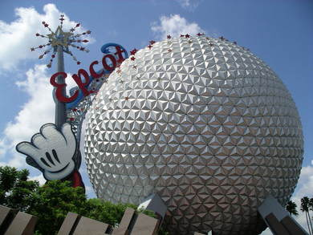  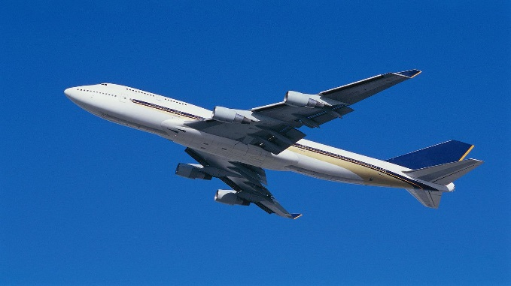 | ARRIVE IN ORLANDO (D)  Day 1:  - Arrive at Orlando Airport. Recommend after 3 pm.  - Meet and greet at the airport,  - Private transfer to hotel Four Points by Sheraton-Studio City or similar.  - Evening – Indian Dinner at Hotel (Walkable distance)  ORLANDO - EPCOT CENTER (B, D)  Day 2:  - Morning – Breakfast.  - Experience the future City today at the Epcot Center. The rides are out of this world. The technological innovation is mind boggling. Spend day and Evening. Hotel-EPCOT RT by shuttle. Please confirm Shuttle timings at front desk at the time of check-in.  - Enjoy the Park.  - Evening – Indian Dinner at Hotel delivered/Walkable distance  Note – Pax wanting to stay back for the Fireworks show will have to make their own arrangements.
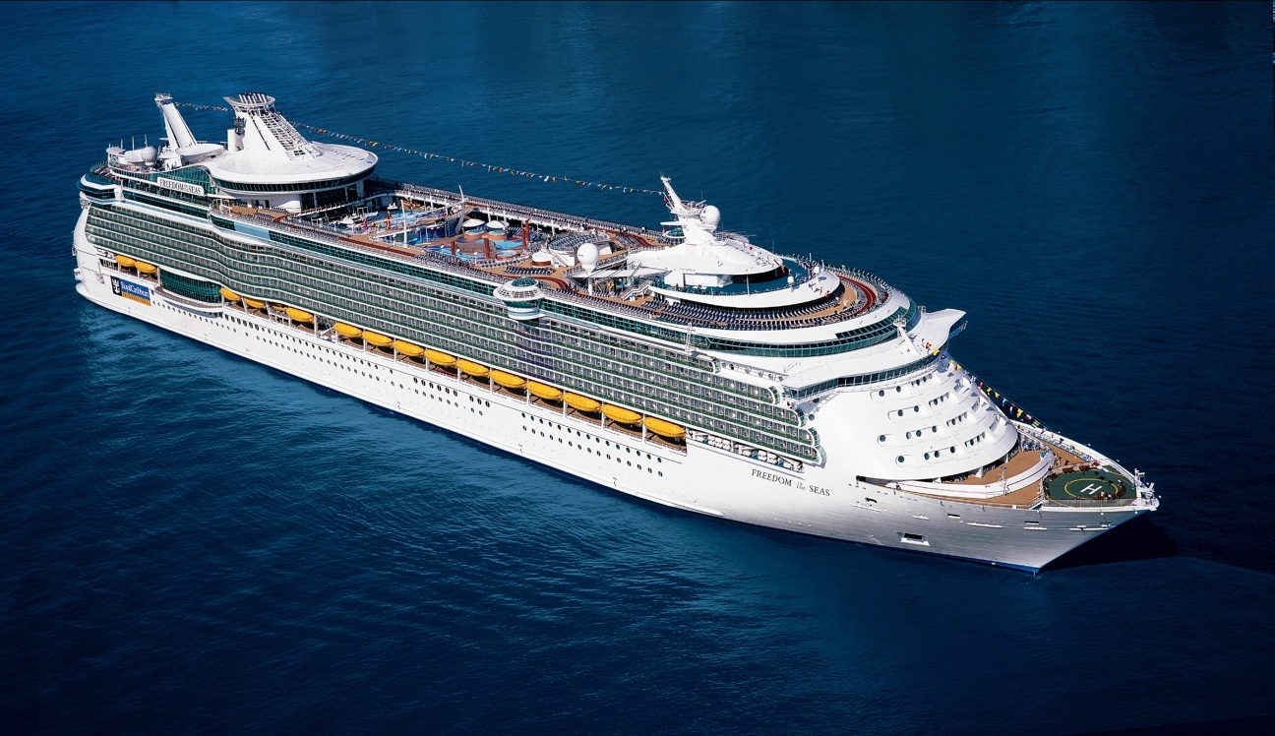 | ORLANDO-CRUISE (PORT CANAVERAL)  Day 3:  - Morning – Breakfast  - Proceed to Port Canaveral for your cruise (Please confirm Hotel shuttle transfer timings to Port Terminal)  - LUNCH/DINNER (ON BOARD)
ORLANDO-CRUISE (ON BOARD)
Day 4:

ON BOARD
ORLANDO-CRUISE (ON BOARD)
Day 5:
ON BOARD
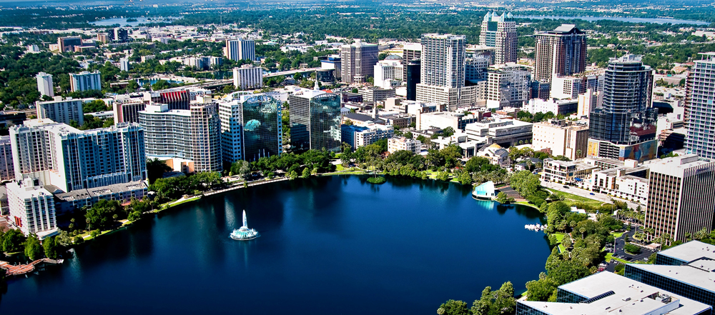 | ORLANDO-FREE DAY ON OWN  Day 6:  Morning –Breakfast on cruise  Pick up from Port terminal by Shuttle (Please confirm timings wit front desk)  Hotel check in 3pm.  Free day to explore Orlando on own  Evening – Indian Dinner (Walkable distance)
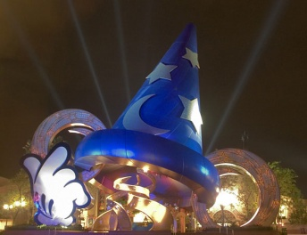 | ORLANDO - MAGIC KINGDOM  Day 7:  - Morning – Breakfast  - Hop to the happiest land, the Magic Kingdom, where the legend of Mickey Mouse begins. The magic will bring you the classical vehicles Western Carriage, Pirates’ Treasure Island and Cartoon stars. Hotel-MAGIC KINGDOM RT by shuttle.  - Enjoy the Park. Please confirm shuttle timings with hotel.  Evening – Indian Dinner (Walkable distance)
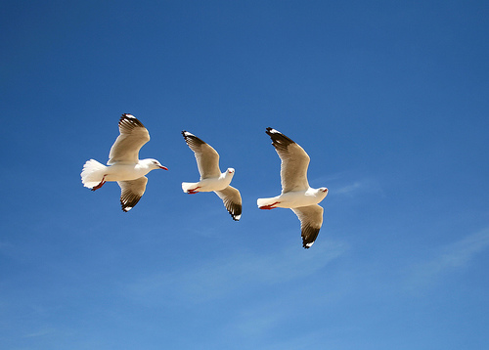 | ORLANDO-LAS VEGAS  Day 8:  - Morning Breakfast  - Private transfer will be provided for your flight to Las Vegas to continue your journey with us.

*THESE TOURS ARE DESIGNED FOR ULTIMATE CUSTOMER COMFORT AND FLEXIBILITY. BARRING ACTS OF GOD AND GOVERNMENT INCLUDING WEATHER CONDITIONS, WAR, NATURAL CALAMITIES, AND CIRCUMSTANCES BEYOND OUT CONTROL ETC. THE TOURS WILL NOT BE CANCELED OR POSTPONED
*CRUISE AND VUSA TICKET PRICES NOT INCLUDED
TOUR PRICE INCLUSIONS
All Entrance Tickets to Sight Seeing Included
- ALL YOUR HOTEL STAYS AT HAND PICKED DELUXE HOTELS.
- 7 DELICIOUS BREAKFASTS, 4 LUNCHES, 7 SUMPTOUS INDIAN DINNERS.
- ALL RQUIRED TRANSFERS BY SHUTLE, SEAT IN COACH, & SEDAN.
- KENNEDY SPACE CENTER.
- DISNEY EPCOT CENTER.
- DISNEY MAGIC KINGDOM.
- UNIVERSAL STUDIOS, ISLAND OF ADVENTURE w/ HARRY POTTER
- MIAMI GUIDED CITY TOUR.
- BAHAMA DAY CRUISE (OPTIONAL).
- KEY WEST DAY TOUR (OPTIONAL).
- FLORIDA EVERGLADES WITH AIRBOAT RIDE, KEY BISCAYNE TOUR (OPTIONAL).

FAQs
- WILL MY TOUR BE ESCORTED? – THIS IS A FIT TOUR. SUPPORT WILL BE PROVIDED FROM CENTRAL AND LOCAL OFFICES.
- AIRPORT MEET & GREET? – INDIVIDUAL MEET AND GREET AT AIRPORTS (NEWARK EWR, NEW YORK JFK, ORLANDO MCO, LAS VEGAS LAS). AIRPORT PICKUP IS INCLUDED IN THE TOUR PRICE FOR THESE ARRIVALS. THE PLACARD WLL READ “TOURS BY TOURS AND PAX NAME”. WE ARE UNIQUE IN PROVIDING THIS SERVICE.
- MEAL PREFERENCE? – INDIAN VEGETARIAN, JAIN, & NON-VEGETARIAN FOOD AVAILABLE FOR DINNERS. THIS PREFERENCE SHOULD BE MENTIONED IN THE TOUR REGISTRATION FORM.
- CLOTHING? – IT IS RECOMMENDED THAT PAX CARRY AT LEAST 2 SETS OF CLOTHES SUITABLE FOR COLD WEATHER. COMFORTABLE FOOTWARE IS A MUST, AS SOME WALKING IS REQUIRED DURING SIGHTSEEING.
- PERSONAL ITEMS? – IT IS RECOMMENDED THAT PAX CARRY PERSONAL ITEMS (TOOTH BRUSH, PASTE, SHAVING ITEMS, COLOGNE, COMB, SMALL UMBRELLA, MEDICINES ETC.) FROM POINTS OF ORIGIN.
- BACK-PACK? IT IS RECOMMENDED THAT PAX CARRY A SMALL BACK-PACK.
- WATER? A BOTTLE OF WATER AND ONE SNACK WILL BE PROVIDED ON THE COACH DAILY.
- DAILY SCHEDULE? A COPY OF TOUR ITINERARY/MAP WILL BE PROVIDED ON ARRIVAL. THE TOUR IS ESCORTED BY AN EXPERIENCED TOUR LEADER/ DRIVER/ESCORT. DAILY WAKE-UP, BREAKFAST, LUNCH, DINNER, ACTIVITY TIMES WILL BE COMMUNICATED TO THE GROUP BY THE TOUR ESCORT ON A DAILY BASIS, OR AS REQUIRED.

TRAVEL INFORMATION
- INTER CITY TRAVEL TIMES (WITHOUT TRAFFIC) –
ORLANDO > KENNEDY SPACE CENTER 1.5 HOURS
ORLANDO > MIAMI BY COACH 4.5 HOURS
- WEATHER –
FOR THE MOST PART WEATHER IS TEMPERATE DURING THE TOUR SEASON. JULY, AUGUST, & SEPTEMBER COULD BE WARM. APRIL & OCTOBER COULD BE COOL. TEMPERATURE RANGE 10-30 DEGREES CELCIUS.
- SAFETY –
TRAVEL IN AMERICA IS SAFE. AMERICA HAS ARGUABLY THE BEST LAW ENFORCEMENT SYSTEM IN THE WORLD. PASSENGERS SHOULD EXERCISE REASONABLE CAUTION IN PROTECTING THEIR BELONGINGS DURING TRAVEL. TOURS LIMITED IS NOT RESPONSIBLE FOR ANY THEFT OR LOSS OF PASSENGER BAGGAGE OR PERSONAL ITEMS.
- VUSA TICKETS REQUIRED–
THE TOUR HAS BEEN DESIGNED TO MINIMIZE AIR TRAVEL.

GENERAL RULES AND REGULATIONS
- ITINERARY CHANGES – REQUEST FOR ITINERARY CHANGES BY PAX WILL NOT BE ENTERTAINED. THE TOUR ESCORT WILL CONDUCT THE TOUR AS PER ITINERARY.
- MEALS MENU– TOURS LIMITED CONTRACTS THE VERY BEST RESTAURANTS AND SPECIFIES MENUS WITH GREAT CARE. MEALS MENU IS PREDETERMINED. HENCE, ANY REQUEST FOR CHANGE TO THE MENU CANNOT BE ENTERTAINED. IT IS NOT PRACTICAL TO CHANGE MEALS MENU AT THE LAST MINUTE ON A TOUR.
- HOTELS – ROOM RESERVATIONS AT HOTELS ARE DONE AS PER THE ROOMING LIST OR NAMES RECEIVED BY TOURS LIMITED. ANY SPECIAL REQUESTS LIKE ADJOINING ROOMS, OR ROOMS IN A PARTICULAR FLOOR OR DIRECTION CANNOT BE GUARANTEED BY TOURS LIMITED. ALSO, CHECK-IN TIME FOR HOTELS IS 3 P.M.. AND CHECK-OUT TIME IS 11 A.M. TOURS LIMITED CANNOT GUARANTEE EARLY CHECK-IN OR LATE CHECK-OUT. HOTELS MAY CHARGE A FEE FOR THIS SERVICE AND PAX IS EXPECTED TO PAY FOR THE SAME.
- MEAL TIMES – BREAKFAST LUNCH & DINNER WILL BE SERVED AT GENERALLY ACCEPTED TIMES DURING THE DAY. REASONABLE FLEXIBILITY IS EXPECTED BASED ON THE ITINERARY AND COACH TRAVEL TIMES.
- BAGGAGE – ONLY 1 STANDARD SUITCASE AND ONE CARRY ON SIZE LUGGAGE IS RECOMMENDED. PLEASE NOTE THAT AIRLINES WILL CHARGE FOR ADDITIONAL LUGGAGE AND WEIGHT. ALSO, TRAVEL IS MORE COMFORTABLE WHEN BAGGAGE IS LIGHT AND IN GOOD CONDITION.

PAYMENT AND CANCELLATION POLICY
- REGISTRATIONS WILL BE ACCEPTED 72 HOURS PRIOR TO DEPARTURE DATE, IF SPACE IS AVAILABLE.
- REGISTRATION FEE OF USD 100 IS NON-REFUNDABLE UNDER ALL CIRCUMSTANCES.
- CANCELLATION POLICY AND CHARGES FROM TRAVEL DATE–
GREATER THAN 30 DAYS – 90% REFUND LESS REGISTRATION FEE OF $100.
30 – 10 DAYS – 50% REFUND LESS REGISTRATION FEE OF $100.
10 DAYS AND LESS – 0% REFUND.

YOUR TOUR PRICE DOES NOT INCLUDE
- DOMESTIC OR INTERNATIONAL AIRFARE.
- PASSPORT, VISA, OR OTHER CONSULAR FEES.
- ITEMS OF PERSONAL NATURE, SUCH AS, TELEPHONE CHARGES, PAY PER VIEW MOVIES, LAUNDRY EXPENSES, OR ALCOHOLIC BEVERAGES Etc.
- ANY OTHER ITEMS NOT MENTIONED IN THIS ITINERARY.
- TRAVEL AND MEDICAL INSURANCE.

Directions to Aashirwad Restaurant in Orlando from Four Points Sheraton Studio City Hotel

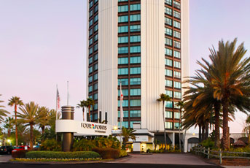
Front of the Hotel 4 points Sheraton Intersection with Kirkman Rd
(Cross the street and turn left, proceed 400 yards past Kirkman Rd intersection and look to right)
_International DR___________________________ _i________International Dr East________________
(Indian Cuisine Aaashirwad located here)
